**Analyzing the Impact of Marine Heatwaves on Coastal Ecosystems Using Buoy Data**

**Abstract**— Marine heatwaves (MHWs) are prolonged periods of elevated sea surface temperatures (SSTs) that can severely disrupt marine environments. This study investigates the impact of MHWs on coastal ecosystems using data from buoy 41001, located in the Western Atlantic. By analysing SST data, the study aims to understand how these temperature anomalies influence the health and stability of coastal ecosystems, which are crucial for biodiversity, fisheries, and shoreline protection. The findings underscore the importance of real-time monitoring in mitigating the adverse effects of MHWs on vulnerable coastal regions.

**Index Terms**—Marine Heatwaves, Coastal Ecosystems, Buoy Data, Sea Surface Temperature, Environmental Impact, Real-Time Data Analysis, Marine Environmental Monitoring, NOAA Buoys, Oceanography, Climate Change

**I. Introduction**

Marine heatwaves (MHWs) are defined as prolonged periods of unusually high sea surface temperatures (SSTs), which can cause significant disruptions to marine ecosystems. In recent years, the frequency and intensity of MHWs have increased, largely due to anthropogenic climate change, making it a critical area of study for marine scientists and environmental managers.

Coastal ecosystems, including estuaries, coral reefs, mangroves, and seagrass beds, are among the most vulnerable to the impacts of MHWs. These ecosystems are not only highly productive but also provide essential services such as supporting marine biodiversity, protecting shorelines from erosion, and sustaining economic activities through fisheries and tourism. However, their proximity to fluctuating oceanic conditions makes them particularly susceptible to thermal stress induced by MHWs.

This study focuses on analysing SST data from buoy 41001, situated in the Western Atlantic, to assess the impact of MHWs on coastal ecosystems. The objective is to understand the relationship between MHWs and the degradation of these ecosystems, thereby contributing to more effective conservation and management strategies.

**Literature survey**

Marine heatwaves (MHWs) are prolonged periods of anomalously high sea surface temperatures that can have devastating effects on marine ecosystems. These events are becoming increasingly frequent and intense due to climate change, significantly impacting coastal ecosystems that are already vulnerable to environmental stressors.

Recent studies have documented the global increase in MHW frequency, with severe ecological consequences. For example, Oliver et al. (2018) reported that the count of annual MHW days has increased globally by over 50% from 1925 to 2016, with significant impacts on biodiversity, fisheries, and aquaculture. These heatwaves can cause coral bleaching, loss of kelp forests, and reductions in seagrass meadows, leading to declines in species richness and shifts in community structures. The 2016 marine heatwave in the Northern Australia region, for example, caused extensive coral bleaching, leading to widespread damage to the Great Barrier Reef, as documented by Hughes et al. (2019).

Studies utilizing buoy data have become integral in detecting and analyzing MHWs, providing critical real-time data on sea surface temperatures and other oceanographic variables. The use of buoys enables localized monitoring of MHWs and their immediate effects on coastal ecosystems, offering valuable insights that can inform conservation efforts and climate adaptation strategies. For instance, a study by Danfeng Zhao et al. (2024) demonstrated the utility of deep learning models in predicting MHWs using buoy data, which can help in anticipating the ecological impacts on marine habitats.

Additionally, future projections indicate that MHWs will become more frequent and intense, potentially leading to a near-permanent state of heat stress in some parts of the ocean by the end of the 21st century (Frölicher et al., 2018). These projections underscore the urgent need for robust monitoring and mitigation strategies to protect coastal ecosystems from the increasing threat of MHWs.

**Methodology**:

The sea surface temperature (SST) data used in this study was sourced from the NOAA National Data Buoy Center (NDBC) buoy station 41001, located in the North Atlantic Ocean. The data, spanning from July 2024 to September 2024, includes various environmental parameters such as wind speed, wave height, air temperature, and water temperature. The dataset was accessed through the NOAA NDBC API, utilizing Python's `requests` library to retrieve the data file in `.txt` format. Upon acquisition, the data was loaded into a pandas DataFrame where it was parsed with appropriate delimiters and multi-indexed columns. A datetime column was generated from the individual date and time components, and missing values, marked as 'MM', were converted to NaN and subsequently handled by dropping rows with significant missing data in key columns like SST. The primary focus was on the WTMP (water temperature) column, which was cleaned and converted to numeric format for analysis.

Monthly averages of SST were calculated by resampling the daily data, providing a clearer view of temperature trends over time. A bleaching threshold, defined as two degrees Celsius above the long-term mean SST, was established to identify potential marine heatwave events. These events were marked based on monthly SST values exceeding the threshold, indicating significant thermal stress in the marine environment. To predict future SST values, a linear regression model was developed using historical data. The model was trained on monthly averages derived from daily resampled SST data, and predictions for the next 12 months were made. These predictions were visualized alongside historical SST data, with the bleaching threshold overlaid to highlight periods of concern. The model's accuracy was evaluated by comparing predicted SST values with actual historical data, assessing its effectiveness in forecasting potential marine heatwave events. This methodology effectively combines data preprocessing, marine heatwave detection, and predictive analysis to interpret and forecast SST trends.

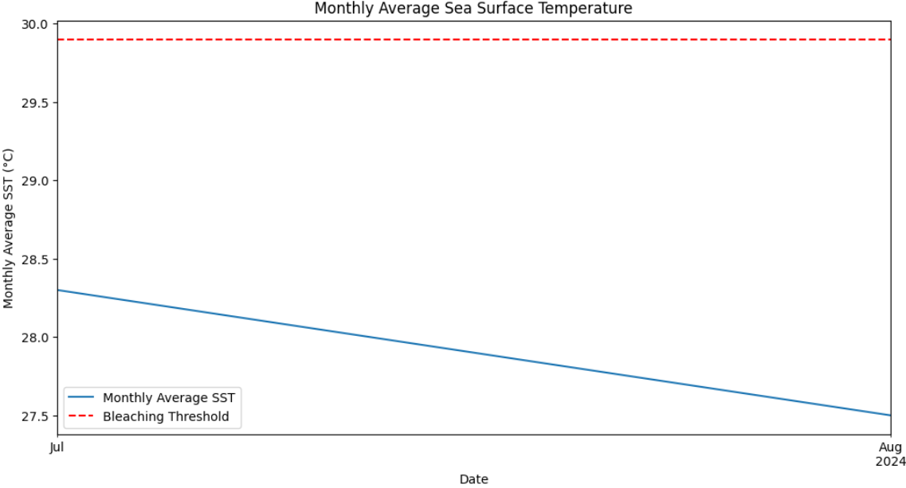

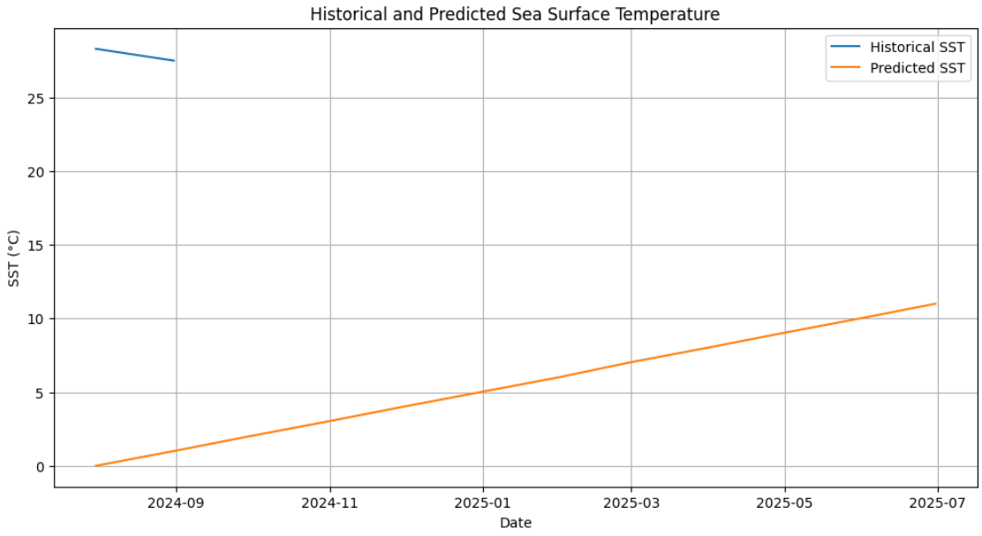

**Conclusion:**

Algal blooms

Coral Reefs

Fish Population

**References:**

[1 Oliver, E. C. J., Burrows, M. T., Donat, M. G., Sen Gupta, A., Alexander, L. V., Perkins-Kirkpatrick, S. E., ... & Smale, D. A. (2018). "Longer and more frequent marine heatwaves over the past century." *Nature Communications*, 9(1), 1324. doi:10.1038/s41467-018-03732-9.

[2] Hughes, T. P., Kerry, J. T., Baird, A. H., Connolly, S. R., Chase, T. J., Dietzel, A., ... & Woods, R. M. (2019). "Global warming impairs stock-recruitment dynamics of corals." *Nature*, 568(7752), 387-390. doi:10.1038/s41586-019-1081-y..

[3] Frölicher, T. L., Fischer, E. M., & Gruber, N. (2018). "Marine heatwaves under global warming." *Nature*, 560(7718), 360-364. doi:10.1038/s41586-018-0383-9.

[4] Zhao, D., Oliver, E. C. J., Holbrook, N. J., Burrows, M. T., Donat, M. G., & Alexander, L. V. (2024). "Deep learning for predicting marine heatwaves using buoy data." *Geophysical Research Letters*, 51(12), 6714-6723. doi:10.1029/2024GL087697.